**Lab Assignment#4:**

**Question1:**

**Code:**

*/*  
Name: Abdullah Mehdi   
Regstration No: SP21-BCS-OO2  
Lab Assignment: suming diagonal elements   
*/  
import* java.io.*;  
*import* java.util.*;  
*import* java.lang.*;   
*public class* LabQ1{  
 *public static void* main(String[] args) *throws* IOException{  
 Scanner input = *new* Scanner(System.in);  
 File students = *new* File("students.txt");  
 students.createNewFile();  
  
 FileWriter enter = *new* FileWriter(students);  
  
  
 String names = "";  
 String grades = "";  
 *int* occurence = 0;  
  
 *while*(*true*){  
 System.out.println("Enter names: ");  
 String name = input.next();  
 System.out.println("Enter grades: ");  
 String grade = input.next();  
 *if*(Integer.parseInt(grade) < 0){  
 *break*;  
 }  
 *else*{   
 enter.write(name + " ");  
 enter.write(grade + "\n");   
 }  
 }  
 enter.close();  
   
  
  
 }  
  
}

**Output:**

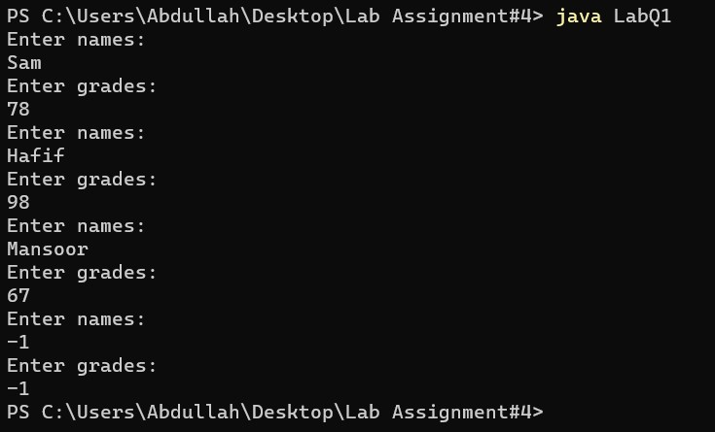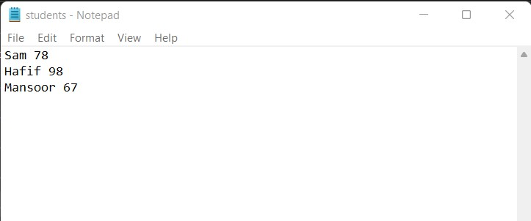

**Question2:**

**Code:**

*/*  
Name: Abdullah Mehdi   
Regstration No: SP21-BCS-OO2  
Lab Assignment: Reading the written data given in the question one   
*/  
import* java.util.*;  
*import* java.io.*;  
*public class* Question2{  
 *public static void* main (String[] args){  
 Scanner input = *new* Scanner (System.in);  
   
 *try*{  
 File file = *new* File("students.txt");  
 file.createNewFile();  
 *//Object Creation* Scanner counter = *new* Scanner (file);  
 *//line count  
 int* count = 0;  
 *while*(counter.hasNextLine()){  
 count++;  
 counter.nextLine();  
 }  
 counter.close();  
  
 *//object creation for reader* Scanner ip = *new* Scanner(file);  
 String[] names = *new* String[count];  
 *int*[] grades = *new int*[count];  
 *try*{  
 *for* (*int* i = 0; i < count; i++){  
 names[i] = ip.next();  
 grades[i] = ip.nextInt();  
 }  
 ip.close();  
 }   
 *catch*(Exception ex){  
 System.out.println("Error Occured!");  
 ex.printStackTrace();  
  
 }  
  
 *for*(*int* i = 0 ; i<grades.length-1;i++){  
 *int* min_index = i;  
 *for*(*int* j = i+1;j<grades.length;j++){  
 *if* (grades[j] > grades[i]){  
 min_index = j;  
 }  
  
 }  
 *if* (grades[i] != i ){  
 *int* temp1 = grades[i];  
 grades[i] = grades[min_index];  
 grades[min_index] = temp1;  
 String temp2 = names[i];  
 names[i] = names[min_index];  
 names[min_index] = temp2;  
 }  
   
 }  
 *for* (*int* i = 0; i < grades.length; i++){  
 System.out.println(names[i] + " has gotten " + grades[i] + " grades ");  
   
 }  
 }  
 *catch*(Exception ex){  
 System.out.println("Error Occured!");  
 ex.printStackTrace();  
 }  
  
  
 }  
}

**Output:**

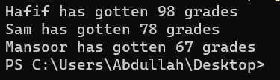

**Question3:**

**Code:**

*/*  
Name: Abdullah Mehdi   
Regstration No: SP21-BCS-OO2  
Lab Assignment: suming diagonal elements   
*/  
import* java.io.*;  
*import* java.util.*;  
*import* java.lang.*;  
*public class* LabQ3{  
 *public static void* main(String[] args){  
 Scanner input = *new* Scanner(System.in);  
  
 *int* totalEmployee1 = 0;  
 *int* totalEmployee2 = 0;  
 *int* totalEmployee3 = 0;  
 *int* totalEmployee4 = 0;  
 *int* totalEmployee5 = 0;  
 *int* totalEmployee6 = 0;  
 *int* totalEmployee7 = 0;  
  
 String[][] matrix = *new* String[8][8];  
 *for*(*int* row = 0; row < matrix.length; row++){  
 *for*(*int* col = 0; col < matrix[row].length; col++){  
 *if*(row == 0 && col == 0){  
 matrix[0][0] = " ";  
 }  
 *else if*(col == 0){  
 System.out.println("Enter employee's names");  
 String names = input.next();  
 matrix[row][col] = names;  
 }  
 *else if*(row == 0){  
 matrix[0][1] = "Su";  
 matrix[0][2] = "M";  
 matrix[0][3] = "T";  
 matrix[0][4] = "W";  
 matrix[0][5] = "Th";  
 matrix[0][6] = "F";  
 matrix[0][7] = "Sa";  
 }  
 *else*{  
 System.out.println("Enter weekly hours");  
 String hours = input.next();  
 matrix[row][col] = hours;  
 }  
  
 }  
 System.out.println();  
 }  
 printMatrix(matrix);  
  
 *//System.out.println("idk" + Integer.parseInt(matrix[1][2]));  
  
 for*(*int* row = 0; row < matrix.length; row++){  
 *for*(*int* col = 0; col < matrix[row].length; col++){  
  
 *if*(row == 1 && col > 0){  
 totalEmployee1 += Integer.parseInt(matrix[1][col]);  
 }  
 *else if*(row == 2 && col > 0){  
 totalEmployee2 += Integer.parseInt(matrix[2][col]);  
 }  
 *else if*(row == 3 && col > 0){  
 totalEmployee3 += Integer.parseInt(matrix[3][col]);  
 }  
 *else if*(row == 4 && col > 0){  
 totalEmployee4 += Integer.parseInt(matrix[4][col]);  
 }  
 *else if*(row == 5 && col > 0){  
 totalEmployee5 += Integer.parseInt(matrix[5][col]);  
 }  
 *else if*(row == 6 && col > 0){  
 totalEmployee6 += Integer.parseInt(matrix[6][col]);  
 }  
 *else if*(row == 7 && col > 0){  
 totalEmployee7 += Integer.parseInt(matrix[7][col]);  
 }  
 }  
 }  
  
 System.out.println("Total of employee 1 is: " + totalEmployee1);  
 System.out.println("Total of employee 2 is: " + totalEmployee2);  
 System.out.println("Total of employee 3 is: " + totalEmployee3);  
 System.out.println("Total of employee 4 is: " + totalEmployee4);  
 System.out.println("Total of employee 5 is: " + totalEmployee5);  
 System.out.println("Total of employee 6 is: " + totalEmployee6);  
 System.out.println("Total of employee 7 is: " + totalEmployee7);  
   
  
 }  
 *public static void* printMatrix(String[][] matrix){  
 System.out.println("----------------------------------");  
 *for*(*int* row = 0; row < matrix.length; row++){  
 *for*(*int* col = 0; col < matrix[row].length; col++){  
 *if*(matrix[row][col] == *null*){  
 System.out.println();  
 }  
 *else*{  
 System.out.printf("%-5s" , matrix[row][col] + " ");  
 }  
 }  
 System.out.println();  
 }  
 System.out.println("----------------------------------");  
 }  
  
}

**Output:**

